1. Login your AWS Console and open CloudFormation console, you may type “CloudFormation” in the left top corner.

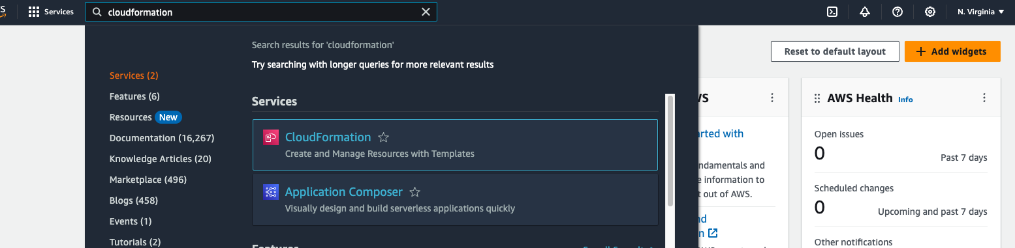

1. In the CloudFormation console, click “Create stack”, and use “Upload a template file”. The template can be download at this link:

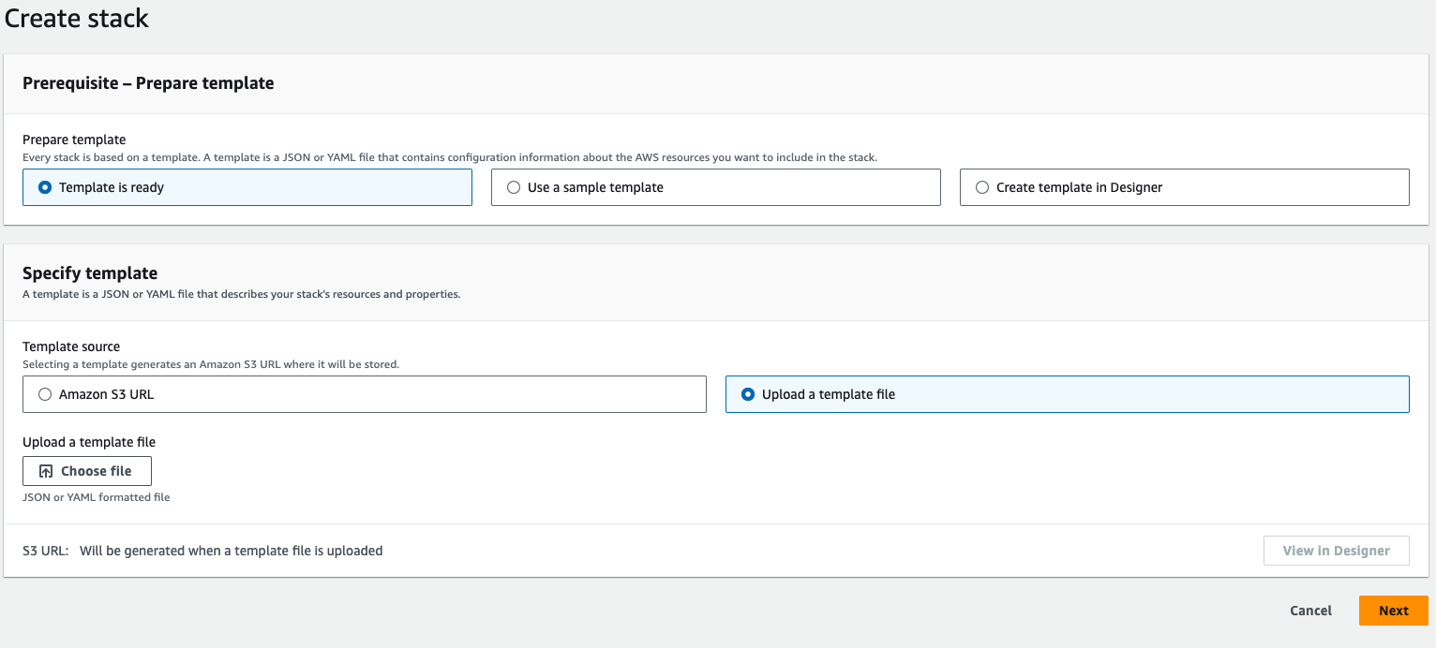

1. Click “Next” and input the stack details:

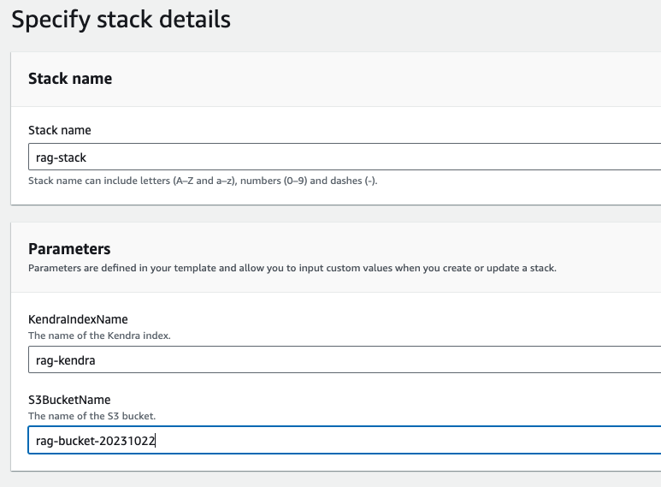

1. Keep the default setting and acknowledge the IAM role creation to create the stack.

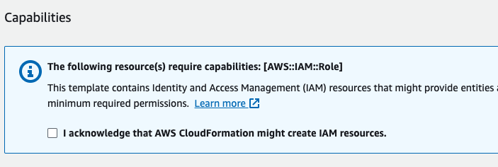

1. If you are the first time to use Amazon Kendra, the creation time will need around 30 minutes. During the CloudFormation creation, we can open SageMaker console for next step. Type “SageMaker” in the top left corner, and open a new tab for SageMaker Console:

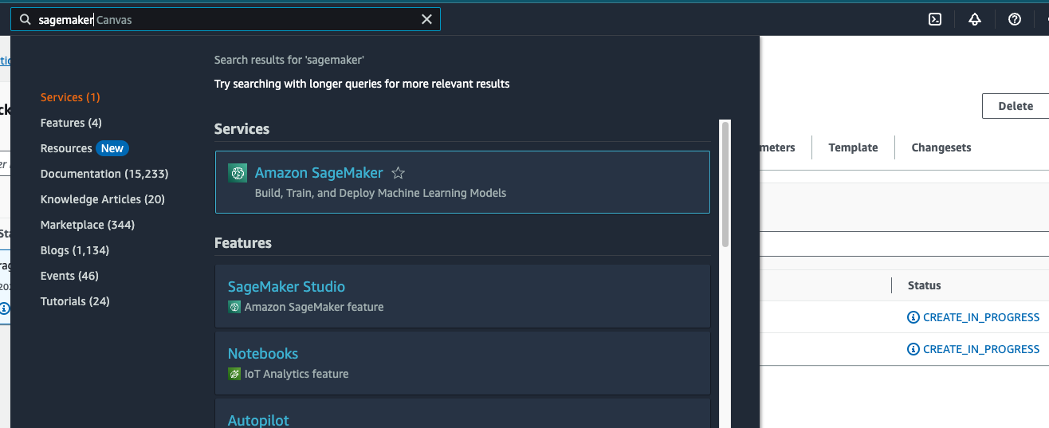

1. In the SageMaker Console, choose “Canvas” at the left navigator bar

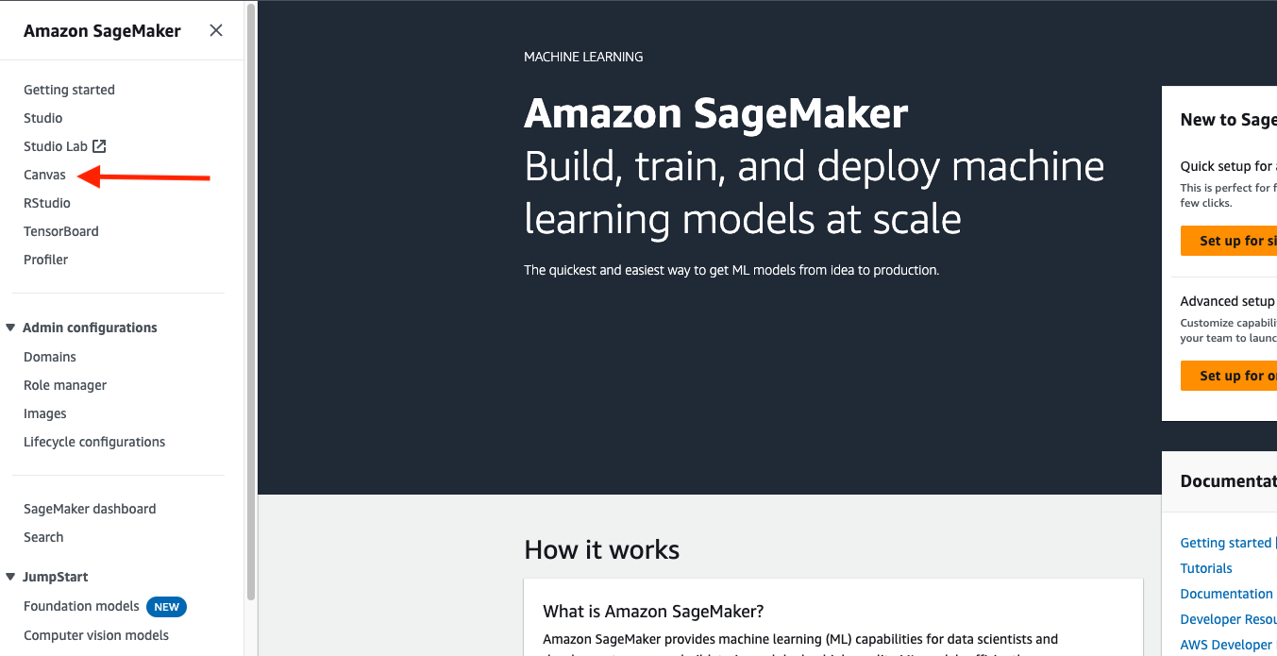

1. If you did not use this feature before, choose “Create a SageMaker domain”:

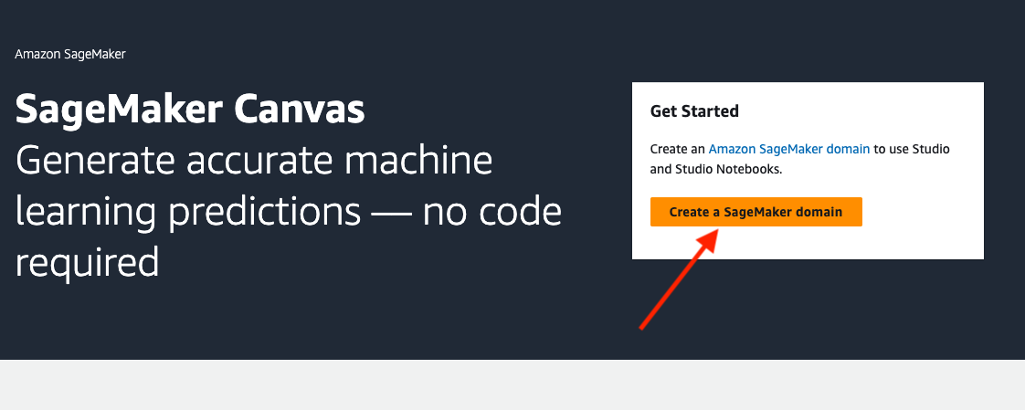

1. Keep the default setting and wait for the domain to be created.

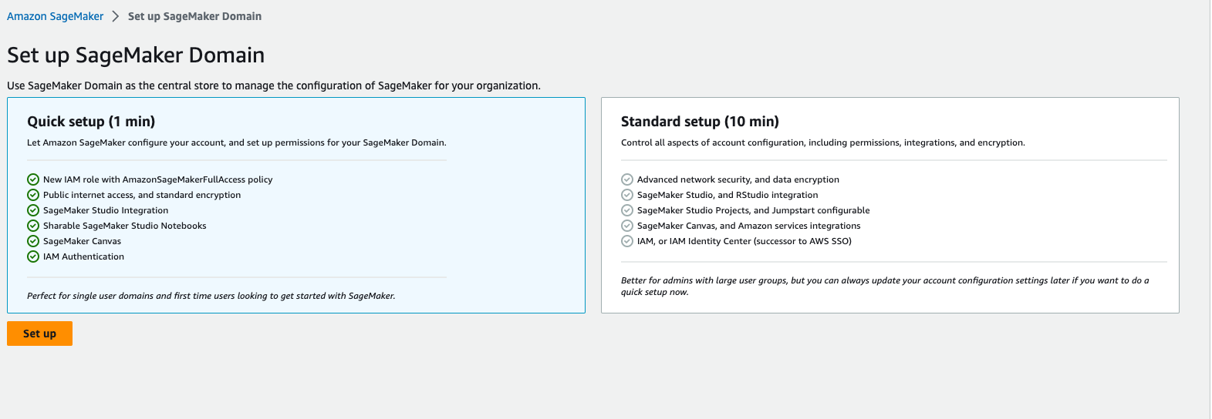

1. Back to the CloudFormation console, if you find “CREATE_COMPLETE” for the stack, go to the “Outputs” tab:

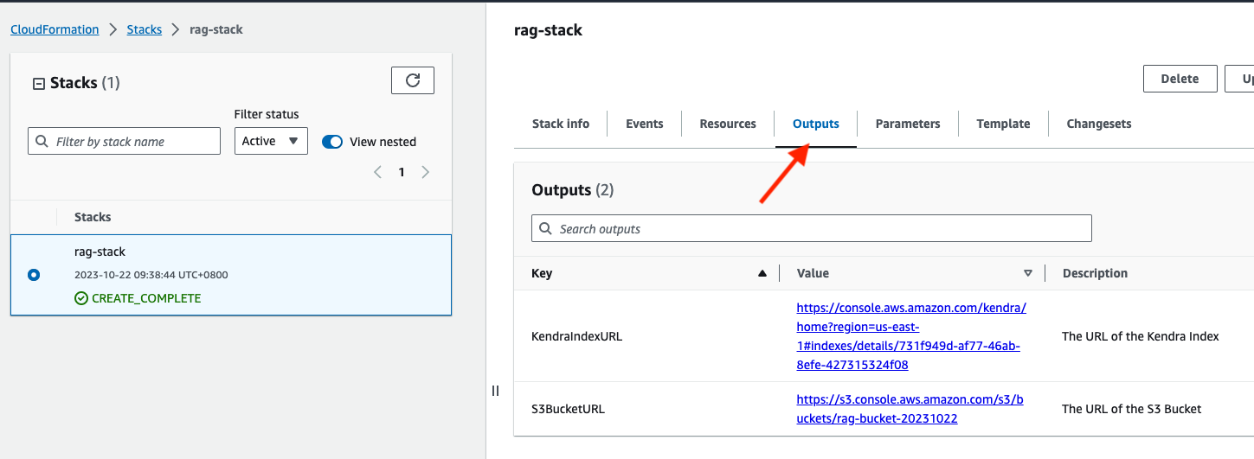

1. Open a new Tab for S3 console by click “S3BucketURL”, drag and drop your ENGLISH document into the console:

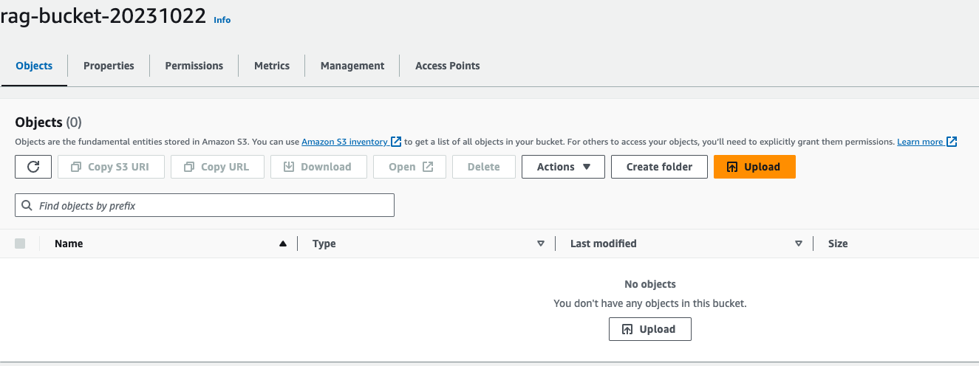

1. Click “Upload”

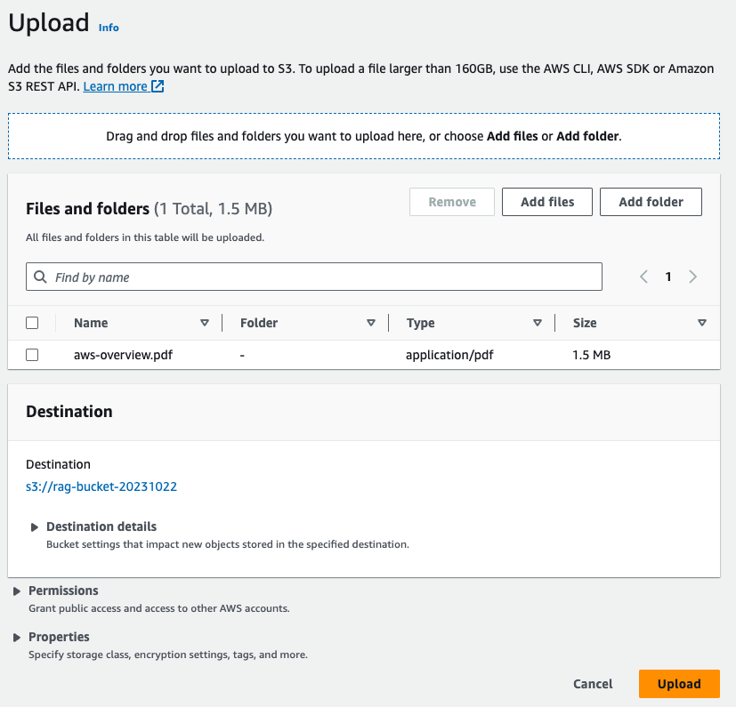

1. Back to the CloudFormation console, open the Kendra console by click the “KendraIndexURL”:

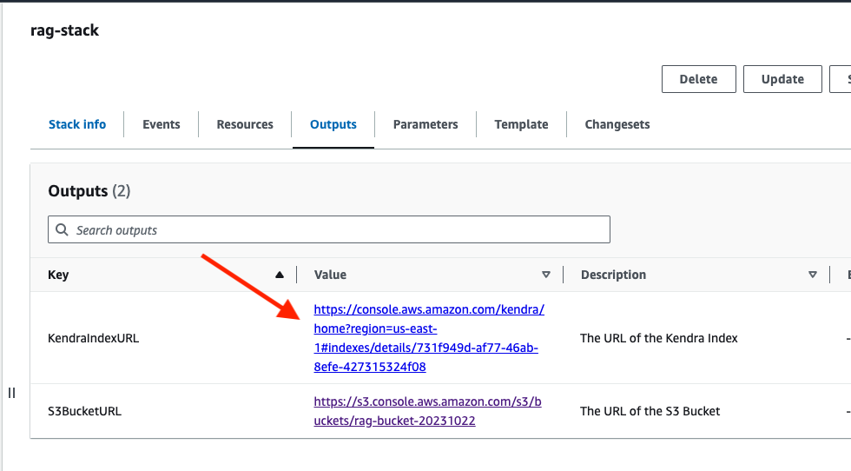

1. In the Kendra console, choose the index:

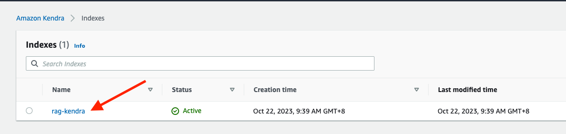

1. Choose “Data sources” at the navigator bar on the left-hand side:

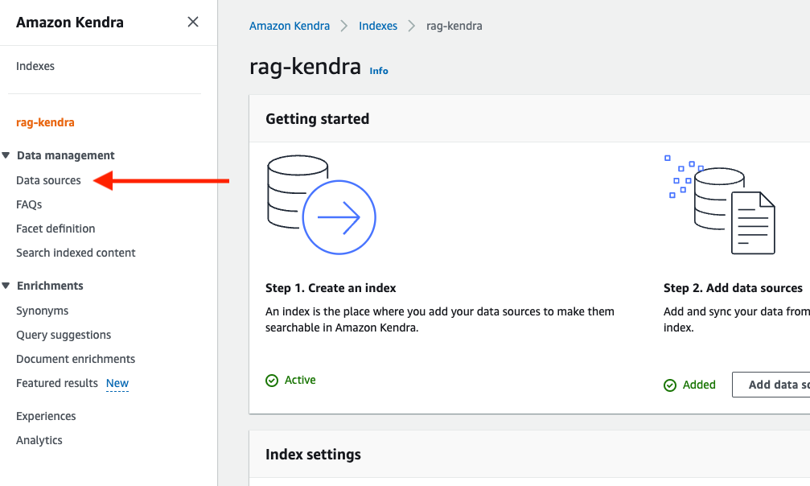

1. Choose the “KendraDataSource” and click “Sync now”, depends on number of documents, it will takes around 5 – 10 minutes.

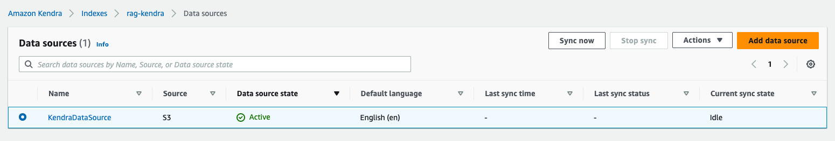

1. After the sync up success, your document has been uploaded and indexed in Kendra:

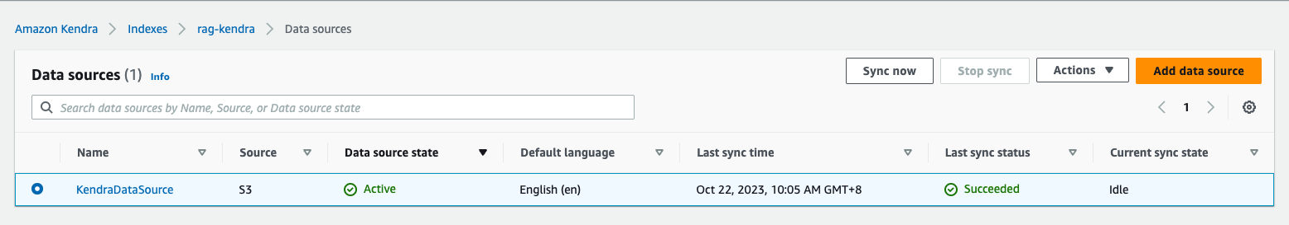

1. Back to SageMaker Console and check the status for Domains:

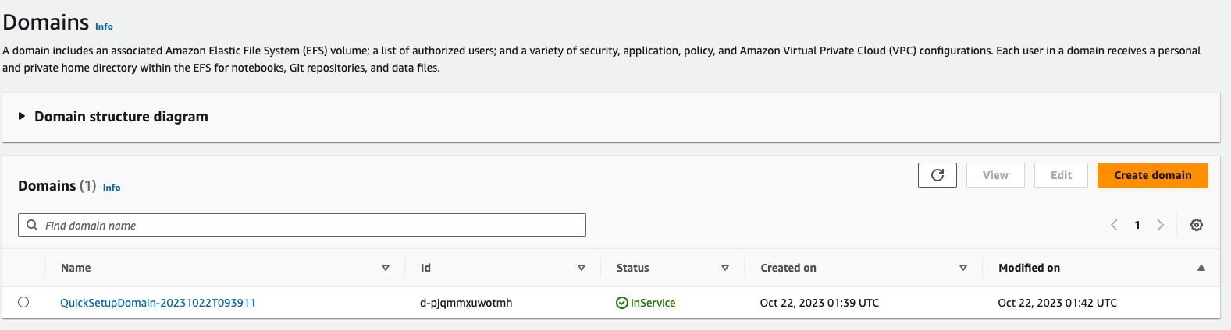

1. If the domain status is “InService”, click “Canvas” in the left navigator bar, and click “Open Canvas”:

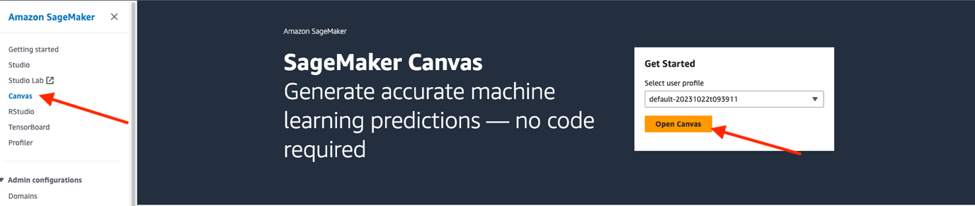

1. If you are first time use SageMaker Canvas, it will take several minutes to create the application:

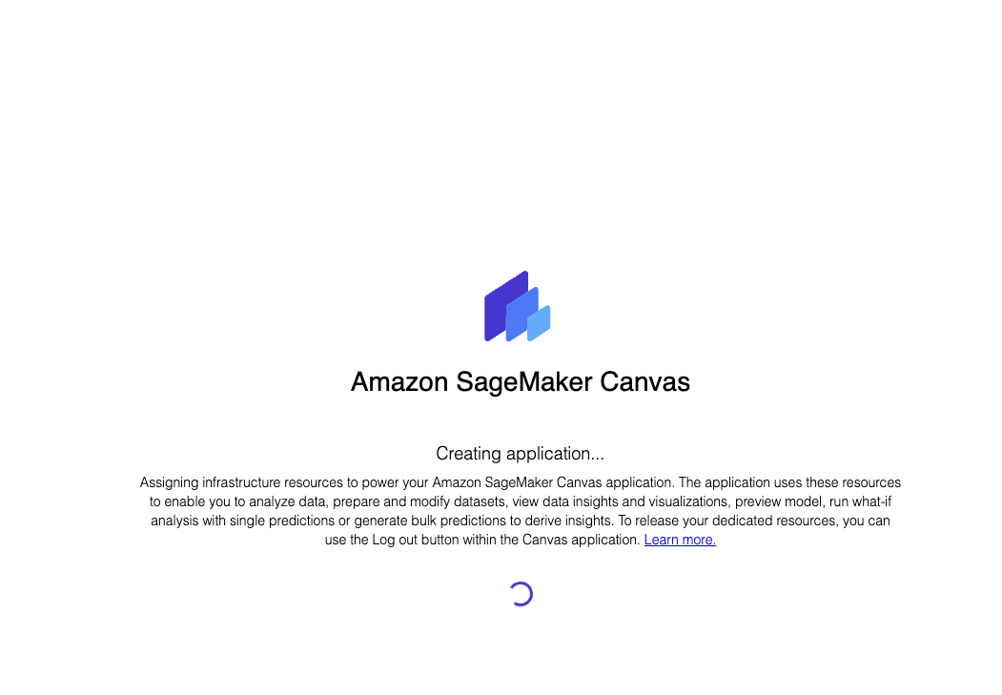

1. Back to the SageMaker domain console, choose the domain and click “Edit”:

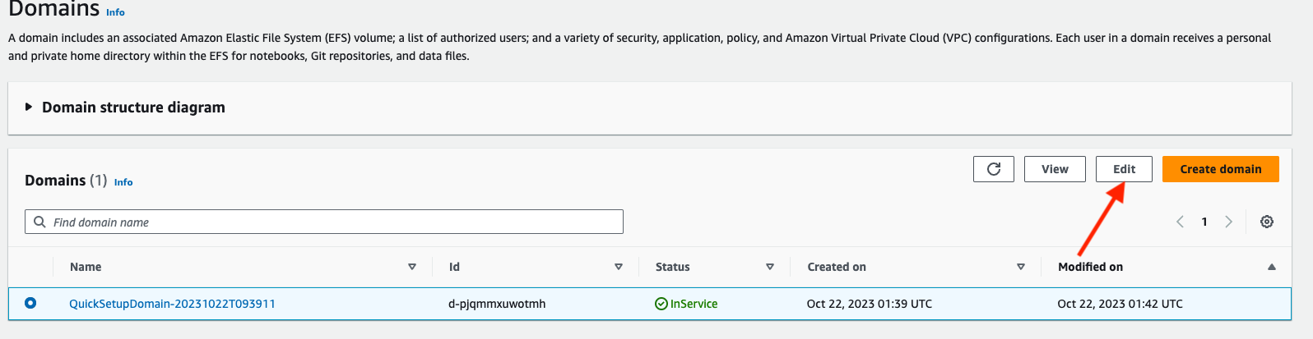

1. Choose “Step4 Canvas Settings”:

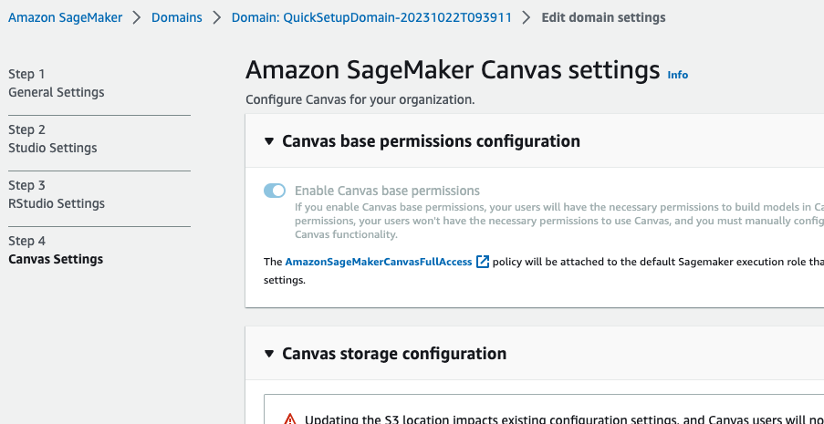

1. Scroll down and find “Canvas Ready-to-use model configuration”, choose “Enable document query using Amazon Kendra”

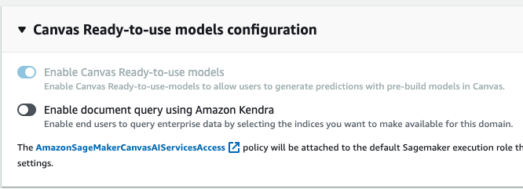

1. Select the Kendra index created:

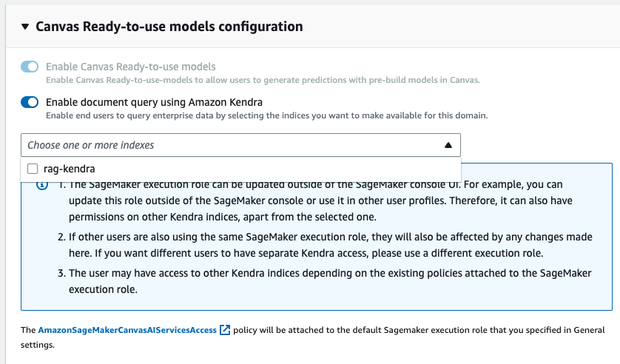

1. Scroll down and click “Submit” at the button.
2. Open Amazon BedRock Console, and choose “Model access” at left hand side:

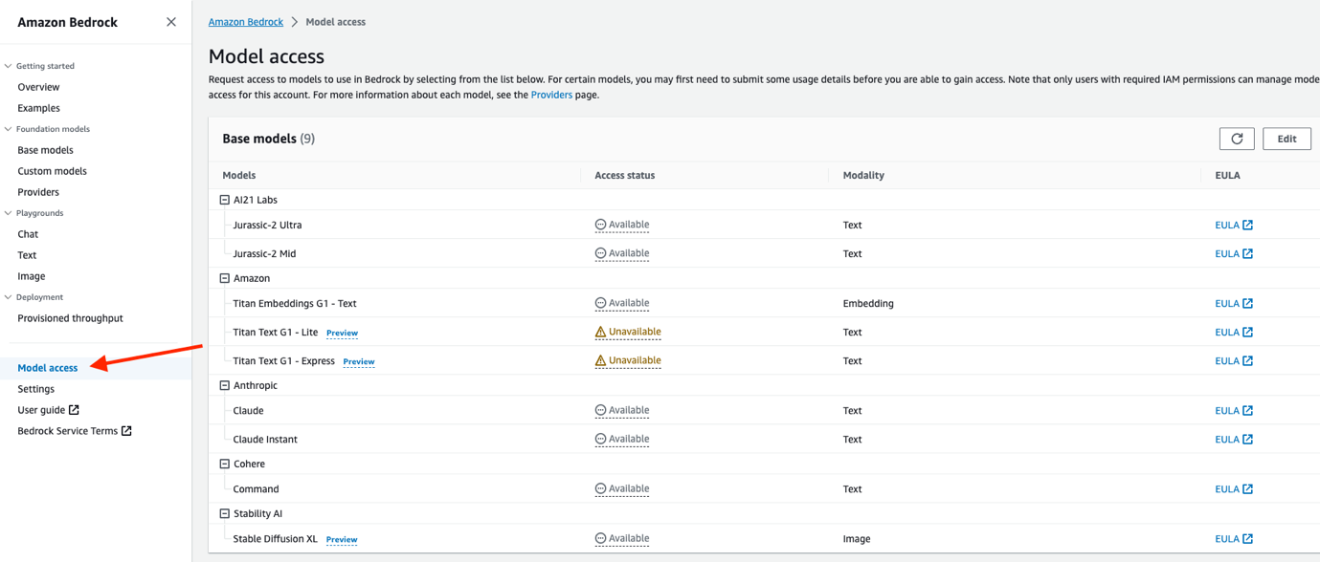

1. Click “Edit” at top right corner, select all the models and click “save changes”:

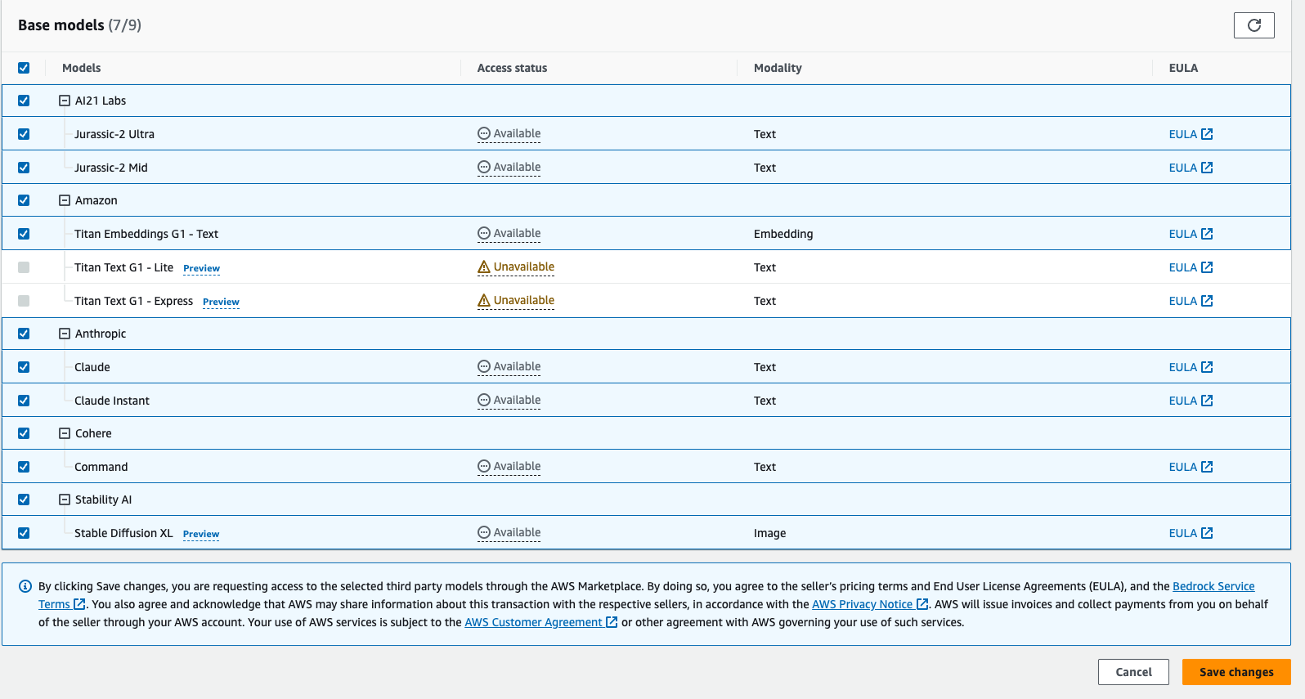

1. Now, access to the models is granted:

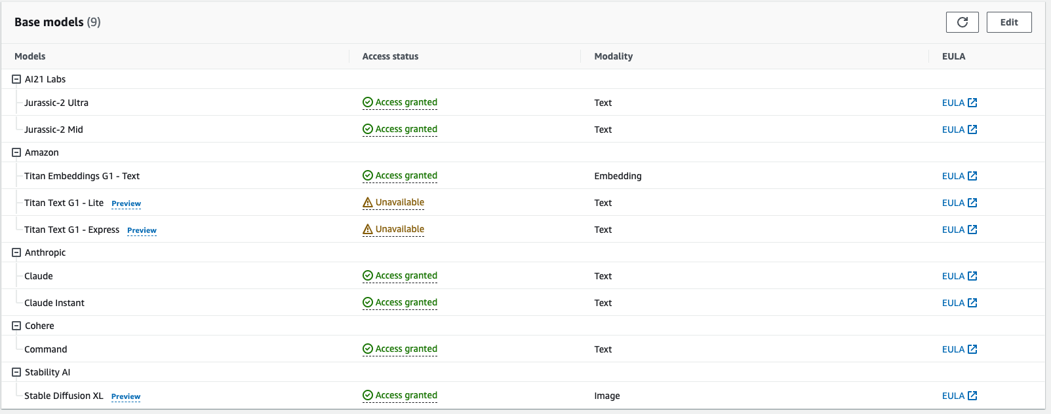

1. Back to the Canvas console, after the application created, you will see below, click skip for now:

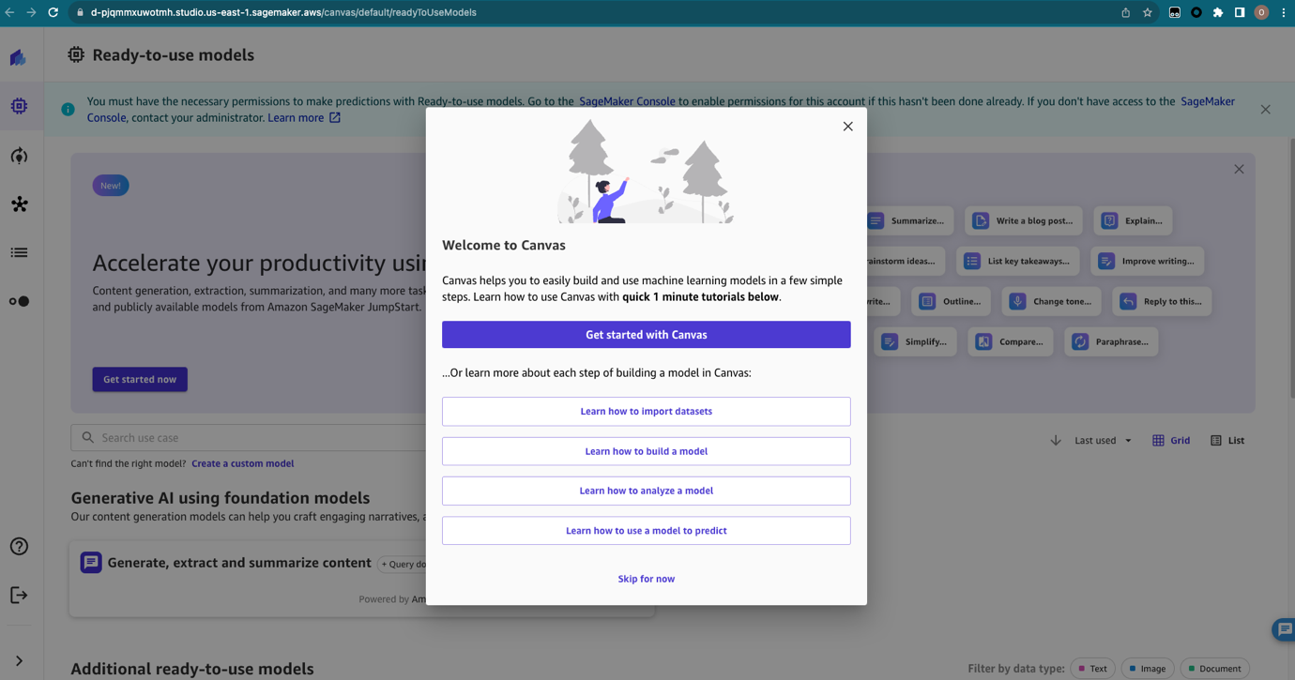

1. Open “Generate, extract and summarize content”:

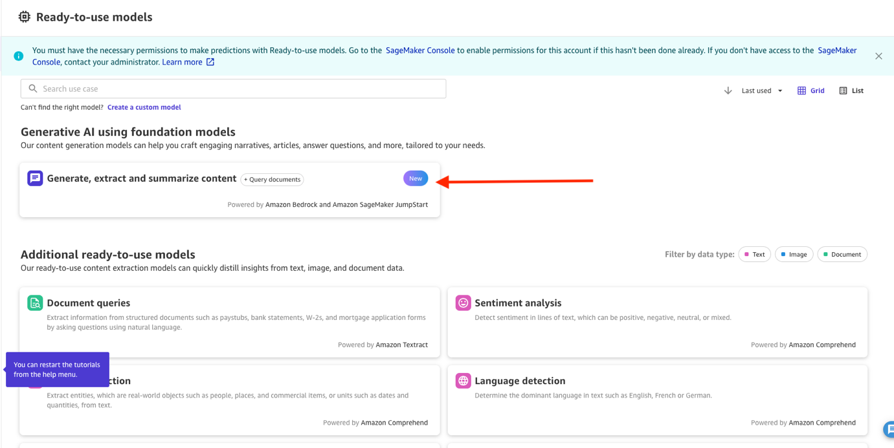

1. Now you can start conversation with the large language model about the document you uploaded. If you do not see the Claude2 model, try to refresh your browser:

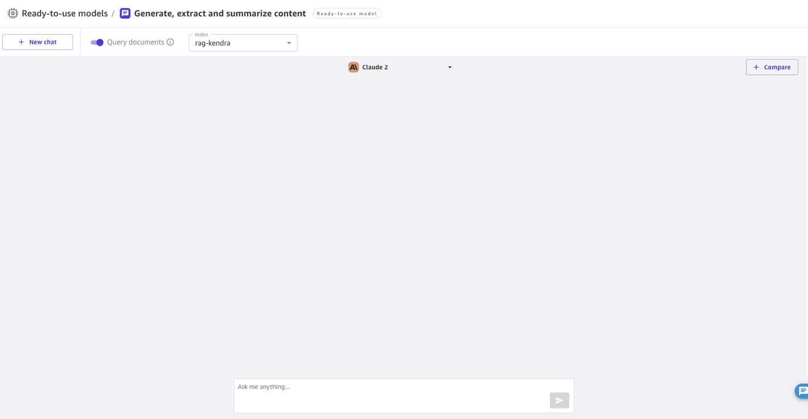

1. Try to ask something related to your document, the language model will give feedback:

